## University Institute of Information Technology

**Faculty of Computing**

|  |  |  |  |
| --- | --- | --- | --- |
| **Course Code:** | CS-432 | **Subject:** | MPL |
| **Lab Manuals** | | **Class/Lab Instructor:** |  |

# -------------------- LAB 06 --------------------

## Learning Objective:

1. String buffer class and its built-in functions.
2. File handling in java.
   * File Creating
   * File Writing
   * File Reading
   * File Deleting

String Buffer

String Buffer mutable sequence of characters. A string buffer is like a String, but can be modified. At any point in time, it contains some particular sequence of characters, but the length and content of the sequence can be changed through certain method calls.

# Built in Function

1. replace()
2. Append()
3. reverse()
4. delete()
5. insert()
6. capacity()
7. length()
8. deleteCharAt()

**Example# 1** replace()

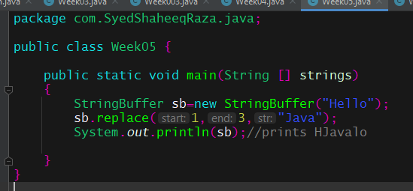

**Example# 2**Append()

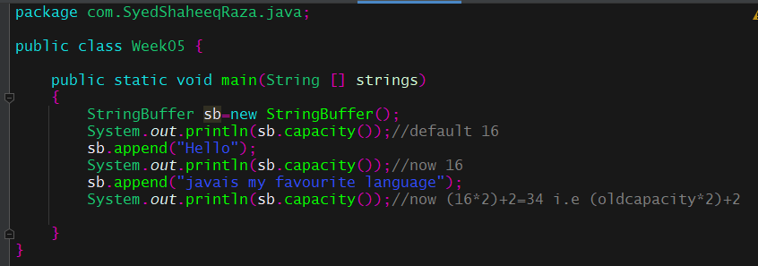

**Example# 3** insert()

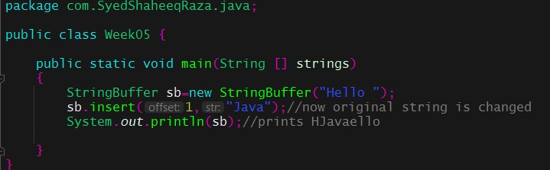

## File Handling in JAVA

File handling in Java is defined as reading and writing data to a file. The particular file class from the package called java.io allows us to handle and work with different formats of files.

**Example# 4** Creating a new file

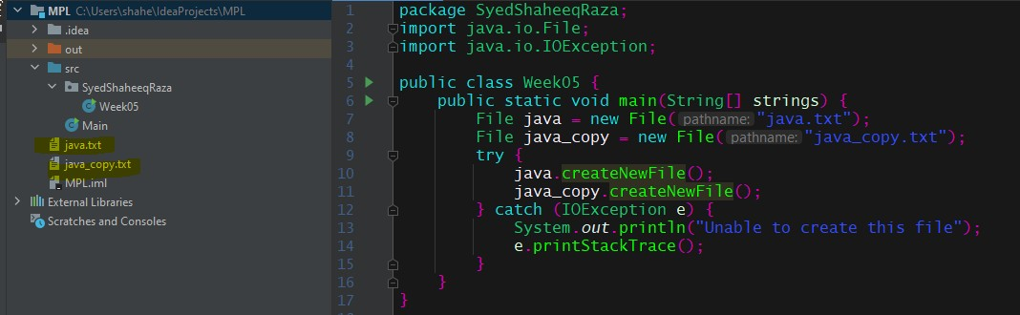

**Example# 5** Writing in a file

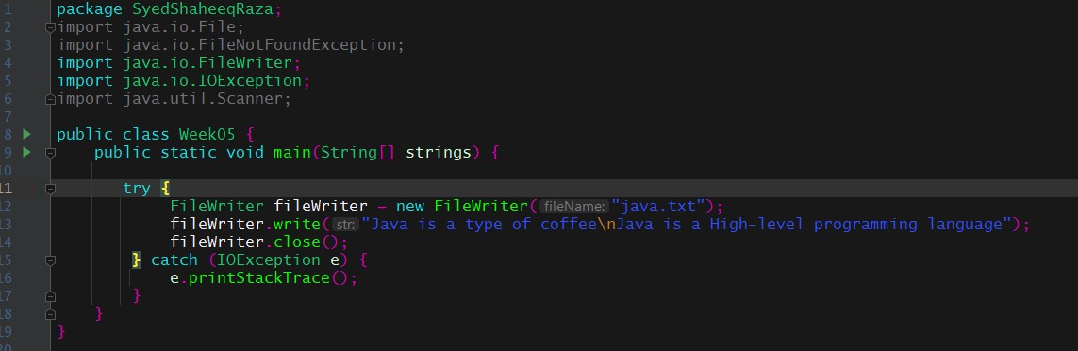

**Example# 6** Reading an existing file

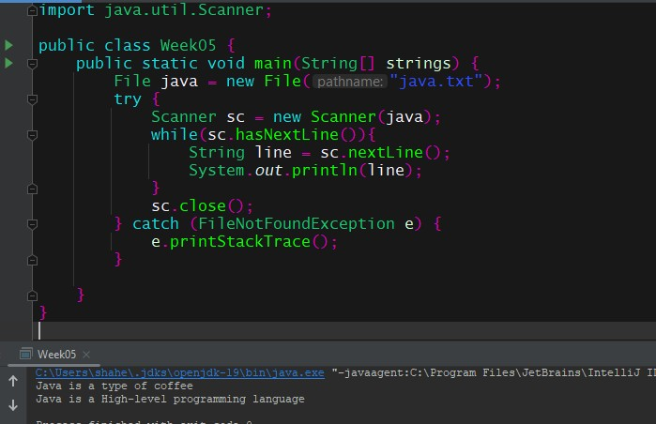

**Example# 7** Deleting a file

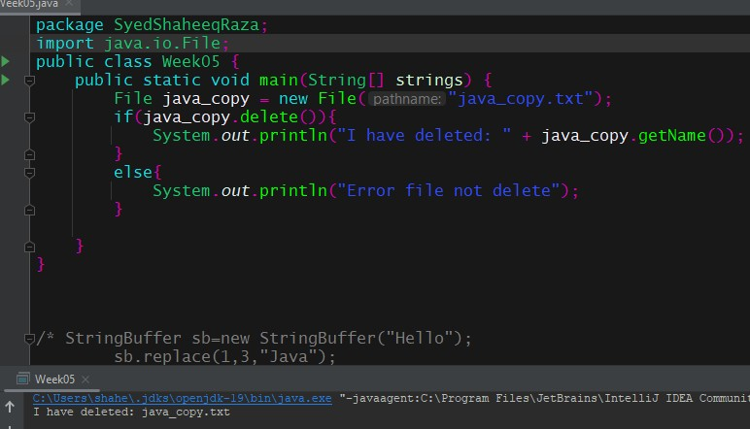

## Lab Task(s)

1. Write a Java programs of String Buffer discuss 8 methods with examples separately.
2. Create a File in java and repeat the following steps:
   * Create
   * Write
   * Read
   * Delete

## Note:

* In this .txt file store your name, ARID number, and final year project idea.
* Add the .txt file screenshot before the deleting step.

Submission Format

Note: Create class name with your name or ARID number.

* e.g: Ali_1, Ali_2
* submit 12 examples.
* Code and output screenshots necessary.
* Share your complete code with images in .doc file or PDF.

**Course Instructor:** Aiman Khan Nazir

Email: [aimankhan@uaar.edu.pk](mailto:aimankhan@uaar.edu.pk)

**Lab Instructor:** Ali Zain

Email: [ranazain0336@gmail.com](mailto:ranazain0336@gmail.com)